Laud Mills

Two CentOS VM’s are needed in this lab. They are referred to as *server* with IP 192.168.100.30/24 and *client* with IP 192.168.100.39/24. Please use the names and IP’s of your VM’s instead.

Make sure to execute iptables -F on both VM’s to flush any active firewall rules.

Also make sure to have users peter, wendy and james on server.

Tutorial: <https://wiki.samba.org/index.php/Setting_up_Samba_as_a_Standalone_Server>

1. Verify that the two VM’s can ping each other.

1. On server start the samba service, then verify its status. Capture a screenshot.

1. Add users peter, wendy and james to the samba database with the smbpasswd command.

1. Create a directory /mnt/shared/info to be accessed in read-only mode by all users. Then, add the following lines to the samba configuration file and test the configuration with “testparam -s”. If it passes the test, then restart the samba service.

[info]

comment = Shared information

path = /mnt/shared/info

public = yes

writable = no

printable = no

1. Add a similar network share for peter and wendy, in which they can collaborate adding or modifying files as needed. Nobody else should have access. Show the lines you added to the configuration file.

[peter_wendy]

comment = Collaboration Share for Peter and Wendy

path = /mnt/shared/peter_wendy

valid users = peter, wendy

writable = yes

create mask = 0660

directory mask = 0770

public = no

printable = no

1. From the client VM, try accessing both shares with “smbclient //192.168.0.30/SHARE -U james” by changing SHARE appropriately. You should be able to access the first share but not the second. Capture screenshots.

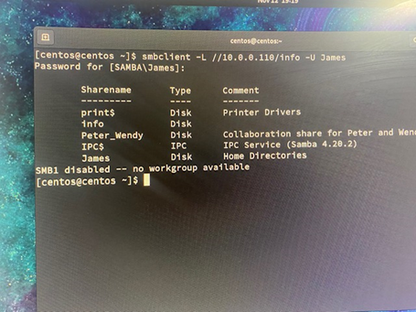

1. Repeat step 6 with users wendy and peter instead of james. Are you successful? Capture screenshots.

1. What configuration would you do for the second share to grant read and write access to wendy and peter, read-only access to james and no access at all to anyone else?

In the /etc/samba/smb.conf file executed by the sudo vi /etc/samba/smb.conf I will add the following script for the second share:

[Second Share]

path = /path/to/share

read only = no valid

users = wendy, peter, james

write list = wendy, peter

read list = james

create mask = 0770

directory mask = 0770